Linear Regression - Complete Learning Handbook

1. Definition
Linear Regression is a supervised machine learning algorithm used to predict continuous numerical values by fitting the best straight line between input (X) and output (Y).

2. Category
Machine Learning > Supervised Learning > Regression

3. Use Cases
House Price Prediction
Salary Prediction
Sales Forecasting
Demand Forecasting

4. Business Problem
Predict Pizza Price based on Pizza Diameter.

5. Formula
Y = mX + b

6. Formula Components
Y = Dependent Variable
X = Independent Variable
m = Slope
b = Intercept

7. Formula Naming
Σ(X−X̄)(Y−Ȳ) = Sum of Cross Products (Covariance Numerator)
Σ(X−X̄)^2 = Sum of Squared Deviations of X (Variance Denominator)
m = Σ(X−X̄)(Y−Ȳ) / Σ(X−X̄)^2 = Slope Formula
b = Ȳ − mX̄ = Intercept Formula

8. Dataset
Diameter (X) | Price (Y)
8 | 10
10 | 13
12 | 16

9. Manual Calculation
Mean(X)=(8+10+12)/3=10
Mean(Y)=(10+13+16)/3=13
X | Y | X-X̄ | Y-Ȳ | (X-X̄)(Y-Ȳ)
8 | 10 | -2 | -3 | 6
10 | 13 | 0 | 0 | 0
12 | 16 | 2 | 3 | 6
Σ(X−X̄)(Y−Ȳ)=12
X-X̄ | (X-X̄)^2
-2 | 4
0 | 0
2 | 4
Σ(X−X̄)^2=8
Slope (m)=12/8=1.5
Intercept (b)=13-(1.5×10)=-2
Final Equation: Y = 1.5X - 2

10. Prediction Example
For X=20
Y = 1.5(20)-2 = 28

11. Graph Visualization
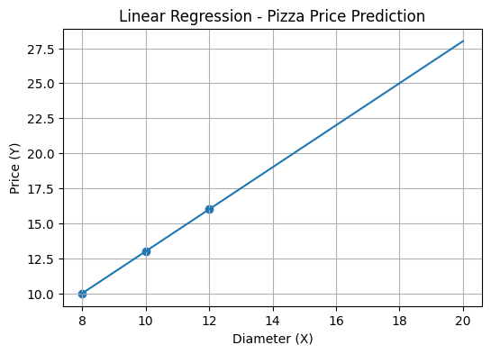

12. Python Implementation (Manual)
X=[8,10,12]
Y=[10,13,16]
x_mean=sum(X)/len(X)
y_mean=sum(Y)/len(Y)
x_dev=[x-x_mean for x in X]
y_dev=[y-y_mean for y in Y]
cross=sum(dx*dy for dx,dy in zip(x_dev,y_dev))
sq=sum(dx**2 for dx in x_dev)
m=cross/sq
b=y_mean-(m*x_mean)
prediction=m*20+b
print(m,b,prediction)

13. Python Implementation (Industry Standard - sklearn)
import numpy as np
from sklearn.linear_model import LinearRegression
X=np.array([[8],[10],[12]])
Y=np.array([10,13,16])
model=LinearRegression()
model.fit(X,Y)
prediction=model.predict([[20]])
print(model.coef_)
print(model.intercept_)
print(prediction)

14. Interview Questions
1. What is Linear Regression?
2. What is Slope?
3. What is Intercept?
4. Why do we calculate Mean?
5. What are assumptions of Linear Regression?
6. What are advantages and limitations?

15. Advantages
Easy to understand
Fast to train
Highly interpretable

16. Limitations
Works best on linear relationships
Sensitive to outliers

17. Project Flow
Data Collection → Data Cleaning → Feature Engineering → Linear Regression → Prediction → API/Dashboard

